Office of Foreign Labor Certification – Permanent Online System

This document will guide you through steps to easily access and edit your account information in the Permanent Online System. You will learn what to do if you forget your username, password, secret question or Personal Identification Number (PIN) and how to manage and create sub-user accounts.

Forgot Your Username, Password, Secret Question or PIN

In the event you forget your PERM password, secret question or answer, username or PIN when attempting to access the Permanent Online System, below are easy steps to obtain this information without having to contact a help desk.

The Permanent Online System (at plc.help@dol.gov) automatically generates an email to the email address entered when the employer registered in the system. Therefore, please ensure you add plc.help@dol.gov (and be-rfi.atlanta@dol.gov) to your Address Book or "Safe List" to avoid emails being filtered as SPAM. Further, please check your SPAM or Junk folder before possibly contacting the help desk.

The following steps should yield immediate resolution in accessing the Permanent Online System and direct you to the appropriate help desk for assistance, if necessary.

- Go to plc.doleta.gov.

- Select the link “Forgot your username and/or password?” directly under the “LOGIN” button.

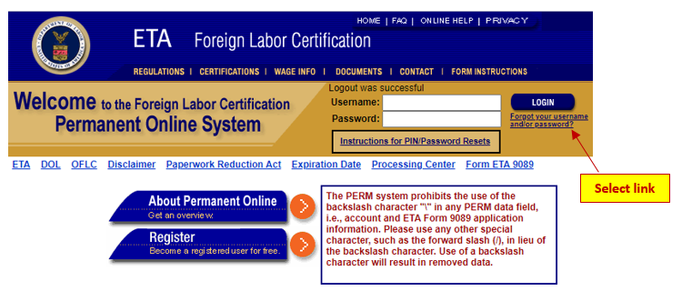

- After accessing the link, scroll down to the applicable section and complete the following, if you forget your:

- Password – enter your username, select your secret question from the drop down option, enter your secret answer and select the “Continue” button. This should result in an email being sent from plc.help@dol.gov and received within 15 minutes.

To see how the employer’s master and employee authorized Permanent Online System user can view and edit the secret question and answer for all of its authorized users, go to how to manage and create sub-user accounts.

After following the above steps, if you are still not able to access your password, send an email with the employer’s name and Federal Employment Identification Number (FEIN) and your username to be-rfi.atlanta@dol.gov. Once processed by the ANPC help desk team, usually within two business days, a temporary password will automatically be sent via the Permanent Online System at plc.help@dol.gov.

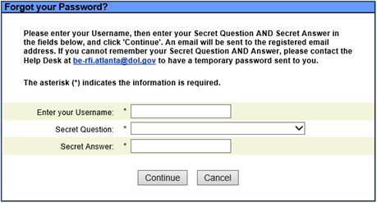

- Secret question – enter your username and select the “Continue” button. This should result in an email being sent from plc.help@dol.gov and received within 15 minutes.

To see how the employer’s master and employee authorized Permanent Online System user can view and edit the secret question and answer for all of its authorized users, go to how to manage and create sub-user accounts.

After following the above steps, if you are still not able to access your secret question, send an email with the employer’s name and FEIN and your username to be-rfi.atlanta@dol.gov. Once processed by the ANPC help desk team, usually within two business days, the secret question will automatically be sent via the Permanent Online System at plc.help@dol.gov.

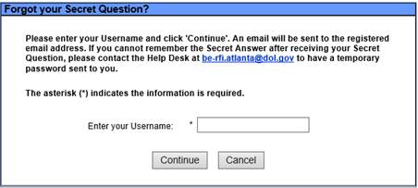

- Username – enter your FEIN or telephone number. Then select your secret question from the drop down option and enter your secret answer. Click the “Continue” button and an email will be sent from plc.help@dol.gov and received within 15 minutes.

To see how the employer’s master and employee authorized Permanent Online System user can view and edit the secret question and answer for all of its authorized users, go to how to manage and create sub-user accounts.

After following the above steps, if you are still not able to access your username, send an email with the employer’s name and FEIN to be-rfi.atlanta@dol.gov. Once processed by the ANPC help desk team, usually within two business days, the username will automatically be sent via the Permanent Online System at plc.help@dol.gov.

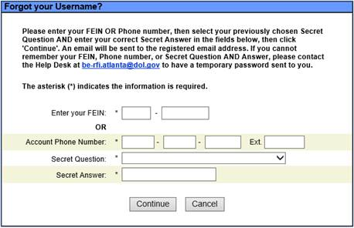

- PIN – enter your username, secret question from the drop down option, secret answer, and select the “Continue” button. An email will be sent from plc.help@dol.gov and received within 15 minutes.

To see how the employer’s master and employee authorized Permanent Online System user can view and edit the secret question and answer for all of its authorized users, go to how to manage and create sub-user accounts.

Please note that all user accounts for the employer will have the same PIN. Therefore, you can ask an approved user account holder that has access to the employer’s account in the Permanent Online System, for the PIN.

After following the above steps, if you are still not able to access your PIN, send an email with the employer’s name and FEIN and your username to be-rfi.atlanta@dol.gov. Once processed by the ANPC help desk team, usually within two business days, your PIN will automatically be generated by the Permanent Online System at plc.help@dol.gov.

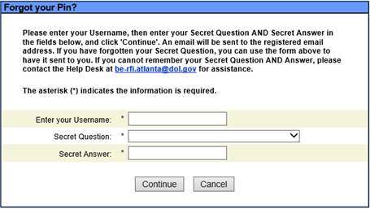

If you experience technical issues, please send an email to plc.help@dol.gov and specify the issue and provide any applicable screenshots.

Important: add plc.help@dol.gov and be-rfi.atlanta@dol.gov to your Address Book or "Safe List" to avoid emails being filtered as SPAM. Check your SPAM or Junk folder before contacting the help desk.

How to Manage and Create Sub-User Accounts

The PERM registration process allows an employer to have one master user account holder (MUAH), associated with its submitted FEIN and username in the Permanent Online System. The MUAH is the person identified in the “User Profile” section when the registration account is created in the Permanent Online System. The MUAH will have access to all PERM online applications submitted on behalf of the employer.

The MUAH has the option to create sub user accounts for employees working for the employer and an authorized representative(s) (agent or lawyer/attorney) that the employer authorizes to represent the employer in submitting PERM applications. The authorized representative may represent the employer throughout the labor certification process.

It is highly recommended, that the employer create a sub-account for at least one of its employees and that the employee is provided with the same authorization and security access as the MUAH. If the MUAH creates sub user accounts for the employer’s employee(s) and/or authorized representative(s), these individuals can submit PERM applications on behalf of the employer. The MUAH also has the ability to delete sub user accounts.

Depending upon the security access granted by the MUAH, the designated authorized representative sub user account holder (SUAH) can create, edit, add, reuse and withdraw applications that they entered in the Permanent Online System. In addition, the SUAH will be able to easily and directly upload documents for applications that are submitted in the Permanent Online System, which will immediately be available to the Certifying Officer for review. The authorized representative SUAH will not be able to manage other user accounts for the employer nor will it be able to edit the employer’s data.

The employer’s employee SUAH can be granted the same access as the authorized representative and additionally allow the employee SUAH to manage the employer’s user accounts and edit the employer’s data. Having an employee SUAH with the same access as the MUAH is imperative, especially if the MUAH stops working for the employer and there is not another designated employee that has authorization and access to manage the employer user accounts and data.

If the MUAH leaves the employer and an employee SUAH does not have the same access as the MUAH in the Permanent Online System, the employer will have to re-register and the previously created and submitted PERM applications will not be able to be accessed by the employer.

Important: the employer’s name and FEIN cannot be edited once entered in the Permanent Online System. If the employer’s business name changes, the employer must re-register in the Permanent Online System.

For security purposes and to ensure integrity of the PERM applications, the Permanent Online System login credentials for the MUAH and SUAH should not be shared.

MUAH and SUAH – change user, login information and secret question and answer

- Edit user’s information
- Log into the Permanent Online System at plc.doleta.gov;
- Go to the “MY PROFILE” tab;
- Go to the “USER INFORMATION” sub-tab;
- Edit the desired information, which includes the user’s first name, middle initial and last name, address, telephone number and email address.
- Confirm your email address.
- Select the “Save” button.

- Edit user’s login information and change secret question and answer
- Log into the Permanent Online System at plc.doleta.gov;
- Go to the “MY PROFILE” tab;
- Go to the “LOGIN INFORMATION” sub-tab;
- You have the option to change your username, secret question and answer on this page;
- By selecting the checkbox next to “Select box to change password”, you can add your new password and then confirm the new password by entering it again.
- Select the “Save” button.

MUAH and Employee SUAH – same security access in the Permanent Online System

Following are the instructions on how the MUAH and the employee SUAH, with the same authorized security access, can edit/change the employer’s name, point of contact, add or edit security access and add new user account(s).

- Change Employer Business Information and Employer Point of Contact:
- Log into the Permanent Online System at plc.doleta.gov;
- Go to the “EMPLOYER DATA” tab;
- Edit the desired information. The information that can be edited includes:
- The employer’s mailing address, telephone number, North American Industry Classification System (NAICS) code and the year the business commenced (this information will appear in Section C of the PERM application); and
- The first name, middle initial and last name, mailing address, telephone number and email address for the employer’s point of contact information can be edited, which appears in Section D of the PERM application).
Note: The edited information will be reflected on future submitted online PERM application(s).
- Confirm your Employer Contact email address.
- Select the “Save” button.

- Create and Edit SUAH accounts:
- Log into the Permanent Online System at plc.doleta.gov;
- Go to the “USER ACCOUNTS” tab;
- Activate user account by selecting the “Activate User Account” button.
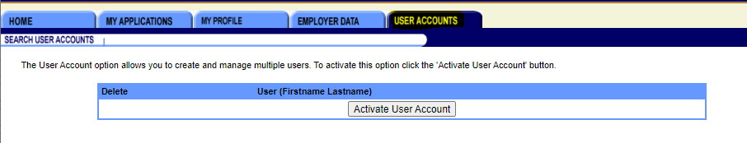
- Select the “Add New User” button.
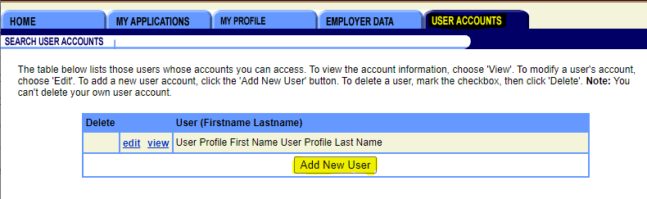
- Complete the information for the new user, which includes the name, address, telephone number, select the user type (Agent, Employee or Lawyer) from the drop down option, and include email address and username for the designated sub-account user.
The security access will automatically default for the sub-account user to have access to edit, add, reuse and withdraw applications. Any security access options can be de-selected; for example, not allowing the user to withdraw a PERM application.
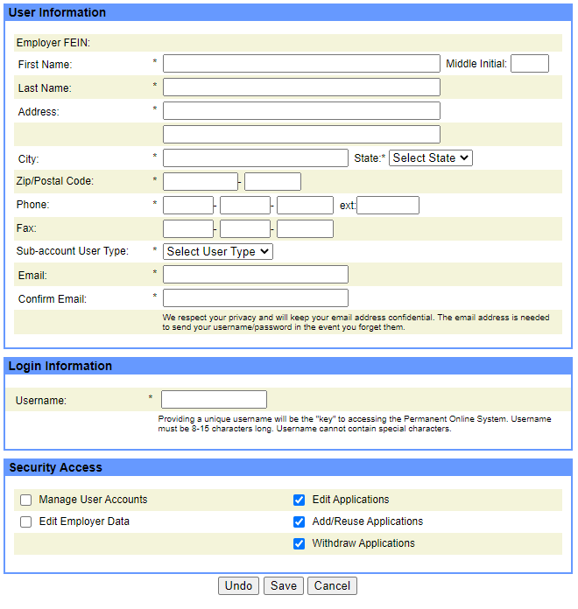
- The MUAH has the option to add security access for the employer’s employees SUAH to “Manage User Accounts” and “Edit Employer Data”.
Note: once a sub account is created for the SUAH, the SUAH will receive an automatic generated email from the Permanent Online System, at PLC.Help@dol.gov, informing the new SUAH that an account has been created by the employer. In addition, the SUAH will be provided with its username, temporary password and a PIN.
The email address PLC.Help@dol.gov should be added to the Address Book or "Safe List" within email system(s) to avoid the email being filtered as SPAM.
- Select the “Save” button.
- The user can view and edit the user’s information (name, address, telephone number, type of user account and email address).
- The user can also delete the sub account by selecting the checkbox under the delete column and then select the “Delete” button.
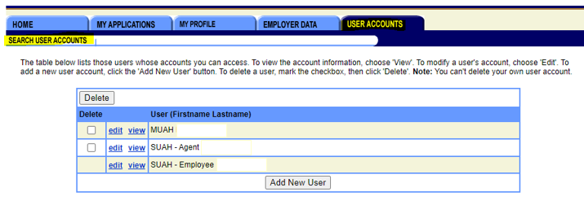
Important: under the “edit” function, the MUAH and authorized employee SUAH can view and edit the secret question and answer for all users. This feature is helpful if a user has forgotten their question and answer.

